NapQueen Assesment

**Data**

1. amazon_marketing_stream_data –

contains hourly trends data for every campaign that is currently running for the products that the brands have been advertised on the amazon.com website.

1. product_mapping - contains data that must be mapped in order to distinguish the product id from the amazon_marketing_stream from the ad_id.
2. product_description - once you get the product id you can further map the product id to understand what the product is.

**Task**

1. Data Preparation:

The dataset includes information about product sales, and all other relevant metrics. Ensure that you import the data into Power BI and perform any necessary data cleaning and transformation to make it suitable for analysis.

1. Dashboard Creation:

Create a Power BI dashboard with interactive visualizations that provide insights into the dataset.

Include relevant charts, graphs, and tables to present the data in a meaningful and actionable way.

The dashboard should have sections that address specific aspects of the marketing stream data, such as

* 1. campaign performance,
  2. sales trends,
  3. conversion rates,
  4. click through rates,
  5. returns of the spends.

1. Analysis:

Showcase your analytical skills by identifying patterns,

trends, and correlations in the data. Generate insights and recommendations based on your analysis.

Provide explanations for any significant findings in the data and suggest possible actions that could be taken based on those insights.

1**. Explanation of Dashboard Creation and Transformations:**

To create the dashboard and arrive at the presented findings, the following steps were taken:

Data Loading and Transformation: The provided datasets (amazon_marketing_stream_data, product_mapping, 3.product_description ) were loaded into Power BI. Data cleaning and transformation steps were performed to ensure consistency and correctness in the data. Columns like "attributed_sales_7d," "time_window_start," and "item_name" were identified as crucial for analysis.

Relationship Establishment: Relationships were established between the datasets using common columns, such as "item_name" and "campaign_id,"asin to ensure data integration and enable cross-filtering.

Campaign Timing Indicators: A calculated table "CampaignTiming" was created to identify the start and end dates of each campaign based on the provided information. This table was used to visualize campaign periods on the line chart.

Visualizations: Visualizations were created using Power BI's visualization options. Bar Charts Line charts were used to depict sales trends over time, with campaign timing indicators as vertical lines to highlight campaign periods.

**DAX Calculations: Various DAX calculations were employed to derive insights:**

Create calculated columns or measures (using DAX - Data Analysis Expressions) to compute metrics like Return of Ad Spends (RoAS), conversion rates, click-through rates, and any other relevant metrics. Measures were created for metrics like total attributed sales, average sales, and growth rate.

Markers and Constant Lines: Markers were added to line charts to indicate campaign timing. Constant lines were used to provide visual cues for specific time periods, such as campaign start and end dates.

Data Slicers: Slicers were added to allow interactive filtering of data based on various dimensions like marketplace, time window, and more.

Analysis: With the dashboard in place, the data was analyzed visually to identify trends, spikes, dips, and correlations between campaigns and sales. The growth rate analysis helped identify products with high growth during campaigns.

The dashboard provides an interactive and visually appealing way to explore and understand the data, allowing users to make data-driven decisions.

**Questions**

1. What marketing campaign(s) had the highest ROI, Return of Ad Spends(RoAS)? Provide visualizations to support your answer.

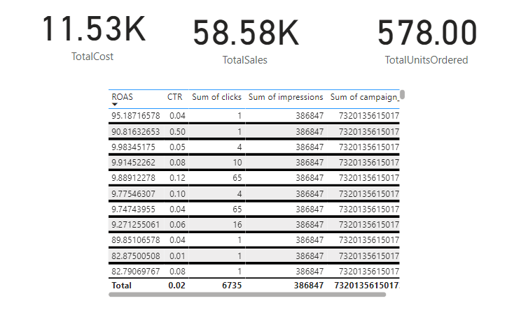

A table visual was created to display campaign metrics such as RoAS, CTR, Clicks, and Impressions. The table was sorted by RoAS to identify campaigns with the highest ROI. Slicers were added for filtering based on various metrics.

Explanation and Analysis:

The table allowed easy comparison of campaign performance metrics. Sorting by RoAS highlighted the campaigns generating the highest returns. Slicers provided interactivity to explore performance variations across different dimensions like marketplace and time window.

2. How does the sales performance vary across different product categories? Present your findings in a suitable chart.

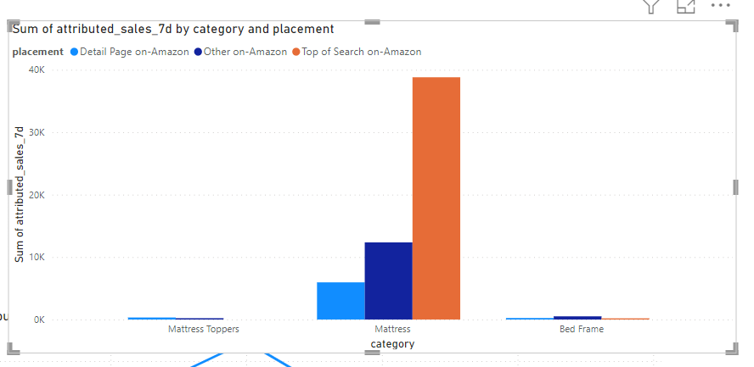

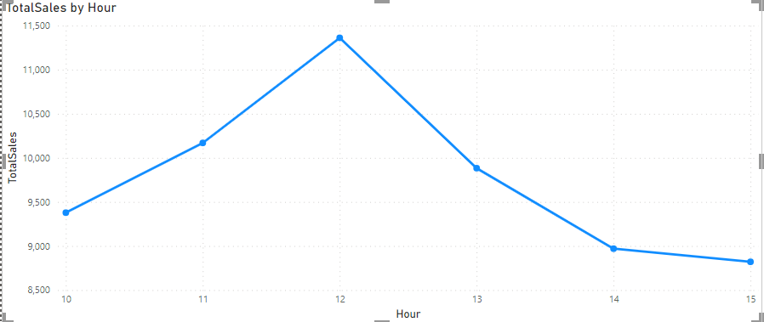

A line chart was used to visualize the overall sales trend over time, with the hour on the X-axis and sales on the Y-axis. A bar chart displayed sales trends for each product category. Slicers enabled filtering by date, marketplace, or other dimensions.

Explanation and Analysis:

The line chart revealed the general trend of sales over time, helping us understand overall sales patterns. The bar chart showcased sales distribution across different product categories. Slicers facilitated exploration of specific timeframes, marketplaces, and categories, aiding deeper insights into sales variations.

3. How does each campaign behave and each item behave hourly?

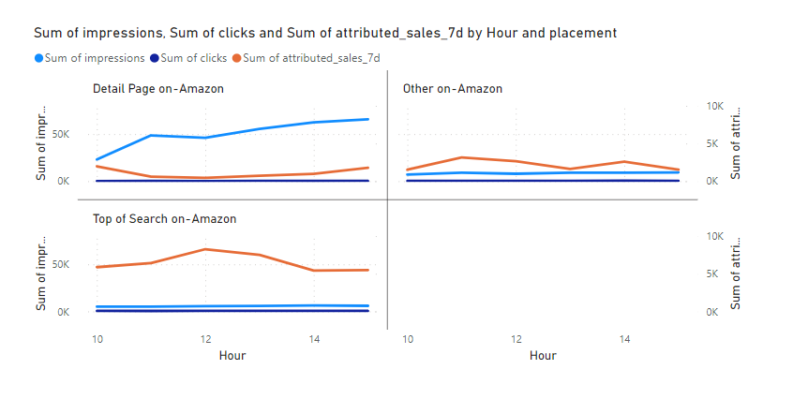

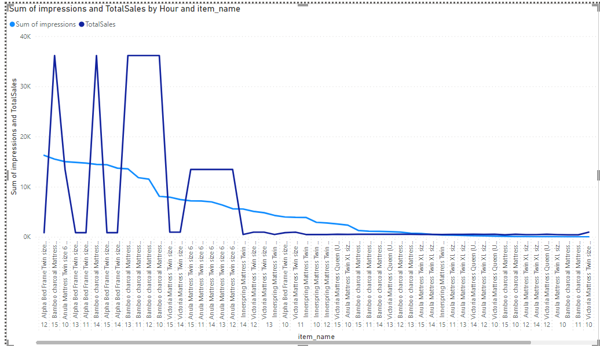

Two line charts were created to showcase hourly behavior. The first chart depicted hourly metrics (impressions, clicks, sales) for each campaign. The second chart displayed hourly metrics (sales, impressions) for each item. This analysis helped understand campaign and item performance throughout the day.

Explanation and Analysis:

The hourly behavior analysis allowed us to identify peak hours for engagement and sales for both campaigns and items. This information can guide decisions about campaign scheduling and inventory management. By studying hourly patterns, we can optimize resource allocation during high-engagement periods.

4. Is there any correlation between the timing of marketing campaigns and changes in product sales?

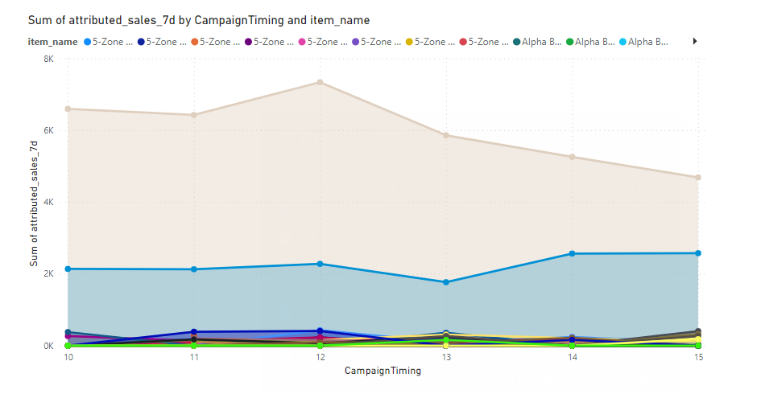

A line chart was generated with sales trend over time, indicating campaign timing. By observing changes in sales during and after campaigns, we assessed whether campaigns influenced sales fluctuations.

Explanation and Analysis:

This analysis aimed to understand the impact of campaigns on sales. By observing sales trends around campaign periods, we could assess whether campaigns led to significant changes in sales volume. This insight is crucial for evaluating campaign effectiveness

5. What is the overall trend of sales before, during, and after each marketing campaign? Are there any significant spikes or dips in sales?

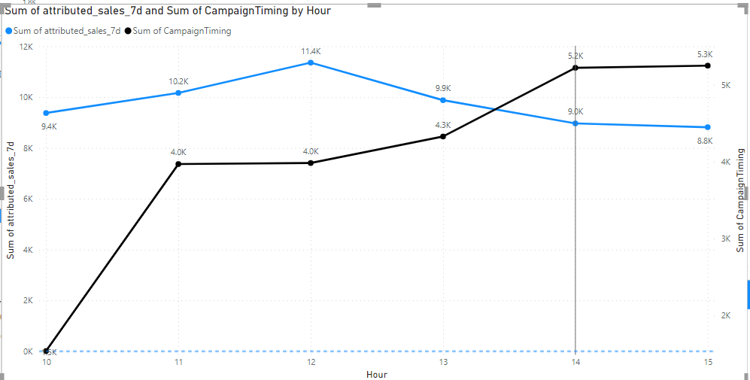

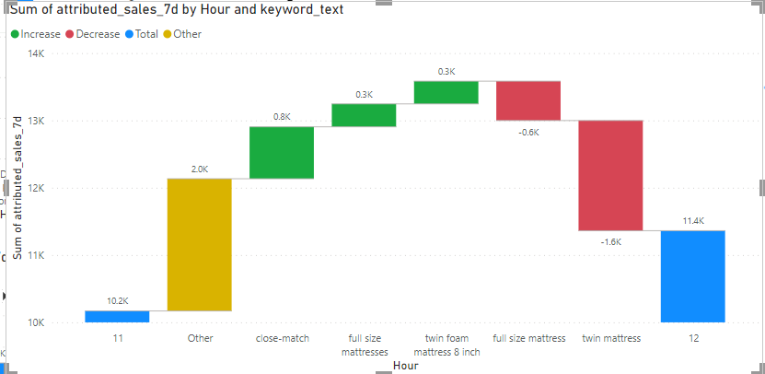

A line chart was created, depicting sales over time with campaign timing indicators. This analysis aimed to identify trends and changes in sales before, during, and after campaigns.

Explanation and Analysis:

By visually inspecting the line chart, we assessed sales trends in relation to campaigns. Spikes or dips during campaigns could indicate their impact. This information helps us gauge the overall influence of campaigns on sales.

6. How can the marketing strategies be optimized to improve overall sales and customer engagement?

Explanation:

Optimizing marketing strategies requires data-driven decision-making. By analyzing campaign performance, sales trends, and customer behavior, we can tailor strategies for maximum impact. Strengthening engagement through targeted content and personalized approaches can contribute to higher conversion rates and customer loyalty.

7. Which products have shown the highest growth in sales during the campaign period? Are there any products that performed poorly during campaigns?

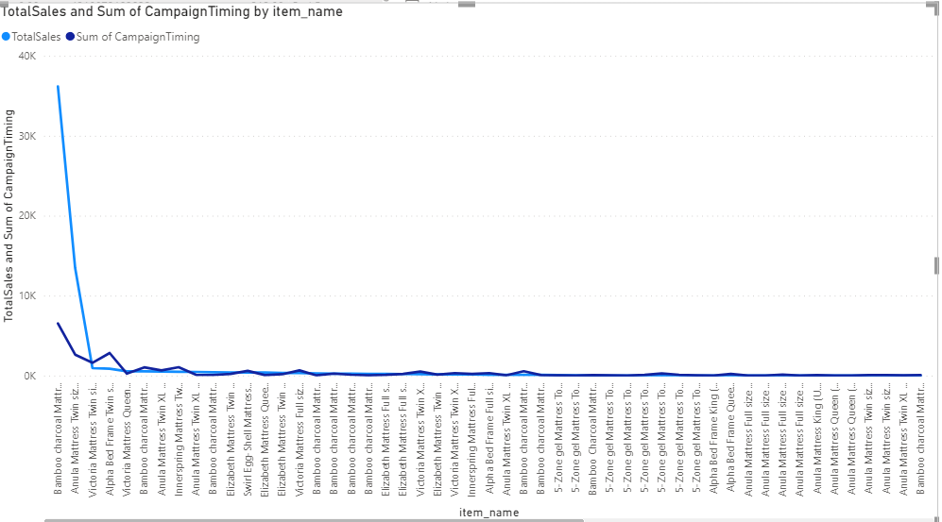

Highly performed Item – Bamboo charcoal Mattress twin size 8

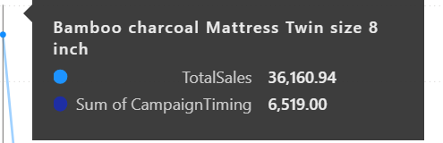

Poorly performed Item – Victoria Mattress twin size 8 inch

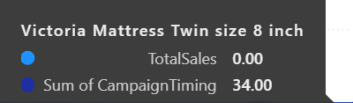

Growth rates were calculated for each product during campaign periods. A matrix visual displayed products with the highest growth and those that performed poorly. Campaign timing indicators were included.

Explanation and Analysis:

By calculating growth rates and using the matrix visual, we pinpointed products with significant sales growth and those needing improvement during campaigns. Campaign timing indicators helped assess correlations between growth and campaign timing. Highly performed Item

Highly performed Item – Bamboo charcoal

8. A sudden change in the dataset format occurs, making it incompatible with the existing Power BI model.

How would you handle this situation while maintaining progress on the dashboard creation?

Data Source Update: If the dataset changes involve new columns, updated column names, or modified data types, need to update your data source in Power BI accordingly. Use the Power Query Editor to make the necessary adjustments.

Backup and Duplicate: Before making any changes to your existing Power BI model, create a backup or duplicate of your current .pbix file. This ensures that you can revert to the previous version if needed

Documentation: Update your documentation to reflect the changes you made to accommodate the new dataset format. This documentation should include details about the changes, any modifications to data transformation steps, DAX adjustments, and visual updates.

Testing and Quality Check: Thoroughly test your updated dashboard to make sure that all visuals, interactions, and calculations are working as expected. Pay special attention to any areas that were directly affected by the dataset changes.